Class Lesson Plan

Class: Grade 7/8 (30 students) Date: Tues Sept 24th, 2019 Lesson Duration: 45 minutes
8:45am-9:30am

Title: Work Period

Unit Plan: Fresh Water and Saltwater Systems – Water usage and cleanliness

Objective of Lesson (in own words):
- Students will utilize this period to finish summative group presentation
- Students will reflect on personal lived experiences as they explore elements of privilege
- Students should either be finishing up their presentations or be at the final stages

Learner Outcomes  Science  - analyze human water uses, and identify the nature and scope of impacts resulting from different uses (Alberta Education, 2014, p. 48)  - provide examples of problems that cannot be solved using scientific and technological knowledge alone (Alberta Education, 2014, p. 48)  - select appropriate methods and tools for collecting relevant data and information (e.g., plan and conduct a search, using a wide variety of electronic sources) (Alberta Education, 2014, p. 48)  Social Studies  - “identify appropriate materials and tools to use in order to accomplish a plan of action” (Alberta Education, 2006, pg. 8)  - “use networks to brainstorm, plan and share ideas with group members” (Alberta Education, 2006, pg. 8)  - “develop a position that is supported by information gathered through research” (Alberta Education, 2006, pg. 9)  - “draw conclusions based upon research and evidence” (Alberta Education, 2006, pg. 9)  English  - present ideas and opinions confidently, but without dominating the discussion, during small group activities and short, whole class sessions (Alberta Education, 2000, 85)  - contribute collaboratively in group situations, by asking questions and building on the ideas of others (Alberta Education, 2000, p. 95)  - take responsibility for assuming a variety of roles in a group, depending on changing contexts and needs (Alberta Education, 2000, p. 95)  - contribute ideas, knowledge and questions to establish an information base for research or investigations (Alberta Education, 2000, p. 95)  - assist in setting and achieving group goals by inviting others to speak, suggesting alternatives, assigning tasks, sharing resources, following up on others’ ideas and listening to a variety of points of view (Alberta Education, 2000, p. 95) | Plan for Diversity  - Have Learning Objective and reminders on board in preparation for class  - Collaborative learning  - Chrome books will be made available  - Provide graphic organizer handout (Appendix A) as a guide to students who may require assistance in organizing presentation  - Track time for students
Prerequisite Knowledge, Skills, Strategies  and Attitudes  - Students should come in with a positive attitude and eagerness to learn alongside peers  - Students will be working on their cognitive skills  - Students should demonstrate their critical analysis and uncovering biases skills  - Students need to be open and respectful towards perspective  - Students will respect their peers as they share class material  - Students will be working on organizational skills | Preliminary Matters (Announcements, etc.)  - Go over Learning Objectives of the period  - Go over responsibility towards peers and self during class discussions  - Assure students that questions are welcome  - Tell students what stage they should be on in the group work

 | Time | What the teacher does. | What the student does. | Resources | Assessment
Introduction | 2 mins.  8:45-  8:47 | - Announcement: Discuss the learning objective for the class  - Announcement: Go over presentation expectations and respectful guidelines. Ensure questions are welcome if they don’t understand  - Ask students to put their hands up in recognition of guidelines  - Inform students where they should be in the stage of their presentation  - Tell students to get into their groups and begin working on presentation | - Get into groups  - Agree to respect guidelines | - N/A | - Formative assessment: check to make sure all students are listening
Work Period | 40  mins.  8:47-  9:27 | - Place graphic organizer handout on table for students who may require it  - Hand back out group presentation boards  - Walk around and make sure students are on track  - Hand out chrome books to students  - Help groups that need assistance  - Track time for students | - Work on their presentations  - Take out Social studies, English, and Science Journals | - English, Science, and Social Studies Journal  - Graphic organizer handout  - Poster Board  - Chrome book  - Class Stationary supplies as needed | - Formative assessment: visually checking to ensure students are on track  - Formative Assessment: Assessing students to see where they are in their work, and where they are with their understanding
Free time/Wrap Up | 3  mins.  9:27-  9:30 | - Ask students to clean up  - Assess where students are and announce if tomorrow will be another work day | - N/A | - N/A | - Formative assessment: scanning to make sure all students are listening

Reflection **How did this lesson go over all? What would you change? What worked well?

Adapted from Alberta Education, Canada, 2008

References
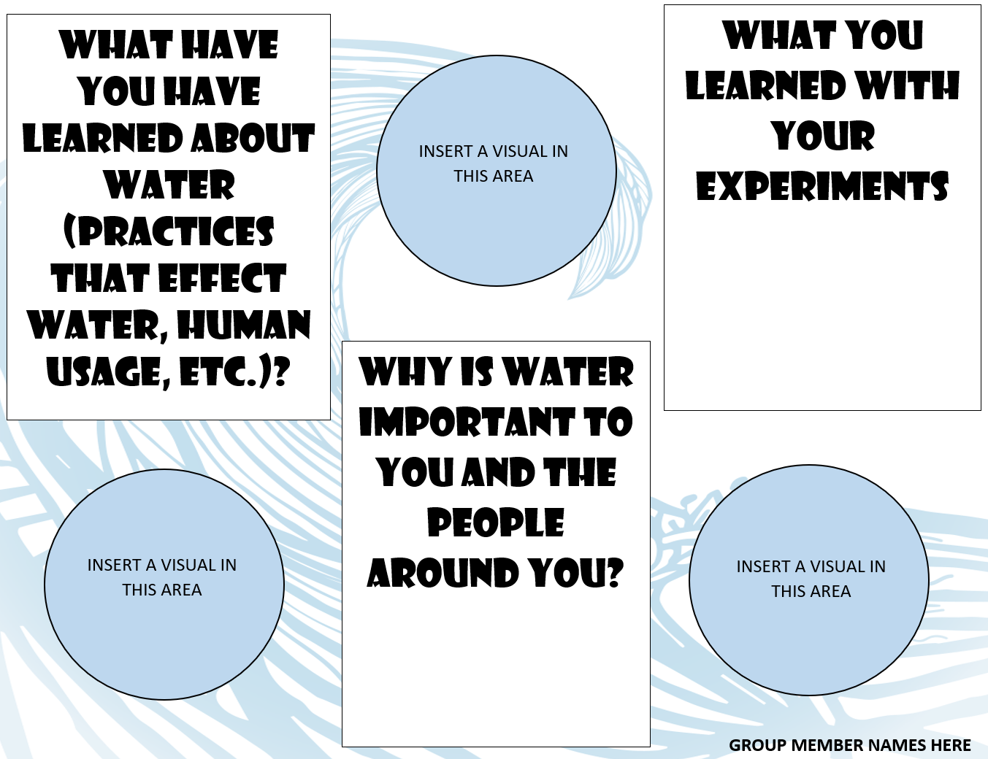
Appendix A

