Class Lesson Plan

Class: Grade 7/8 (30 students) Date: Wed Sept 11th, 2019 Lesson Duration: 45 minutes
8:45am-9:30am

Title: Socrative Class

Unit Plan: Fresh Water and Saltwater Systems – Water usage and cleanliness

Objective of Lesson (in own words):
- Students will perform Socrative teachings by presenting research to class
- Students will reflect on personal lived experiences as they explore elements of privilege
- Students will demonstrate in perspective learning when they ask their peers questions
- Students will be demonstrating their understanding of biases through research process
- Students will participate in in-class discussions and sharpen their cognitive skills by asking peers to comment on “Need to know” questions

Learner Outcomes  Science  - identify science-related issues and problems (Alberta Education, 2014, p. 48)  - identify questions to investigate, arising from science-related issues (Alberta Education, 2014, p. 48)  - analyze human water uses, and identify the nature and scope of impacts resulting from different uses (Alberta Education, 2014, p. 48)  - provide examples of problems that cannot be solved using scientific and technological knowledge alone (Alberta Education, 2014, p. 48)  Social Studies  - “propose and apply new ideas and strategies, supported with facts and reasons, to contribute to problem solving and decision making” (Alberta Education, 2006, pg. 8)  - “identify and use a variety of strategies to resolve conflicts peacefully and equitably” (Alberta Education, 2006, pg. 9)  - “formulate new questions as research progresses” (Alberta Education, 2006, pg. 9)  English  - express personal understandings of ideas and information based on prior knowledge, experiences with others and a variety of oral, print and other media texts (Alberta Education, 2000, p. 11)  - present ideas and opinions confidently, but without dominating the discussion, during small group activities and short, whole class sessions (Alberta Education, 2000, p. 85)  - ask questions or make comments that elicit additional information; probe different aspects of ideas, and clarify understanding (Alberta Education, 2000, p. 85) | Plan for Diversity  - Have Learning Objective and reminders on board in preparation for class  - Provide “Canada’s water usage (CWU)” (Appendix A) worksheet to students for their Social Studies Journal  - Provide time reminders during Socrative presentation  - Collaborative learning  - Guide students through presentations  - Give students choice of who wants to present first  - Offer to read students research question if applicable  - If students can’t answer peer questions, probe students with opened ended questions
Prerequisite Knowledge, Skills, Strategies  and Attitudes  - Students should come in with a positive attitude and eagerness to learn alongside peers  - Students should apply note taking during presentation  - Students should demonstrate their critical analysis and uncovering biases skills through presentation  - Students need to be open and respectful towards perspective  - Students will work on their advocacy voices | Preliminary Matters (Announcements, etc.)  - Go over Learning Objectives of the period  - Go over presentation expectations  - Go over responsibility towards peers and self; before implementing group presentations  - Assure students that questions are welcome  - Track time and guide students throughout the group work

 | Time | What the teacher does. | What the student does. | Resources | Assessment
Introduction | 5 mins.  8:45-  8:50 | - Announcement: Discuss the learning objective for the class  - Ask students to take out Social Studies Journal and CWU from day before  - Announcement: Go over presentation expectations and respectful guidelines. Ensure questions are welcome if they don’t understand  - Ask students to put their hands up in recognition of guidelines  - Ask students to get into their groups for CWU  - Ask for volunteers to present first and write on whiteboard | - Take out Social Studies Journals and CWU  - Agree to respect guidelines  - Get into groups | - Social Studies Journal  - CWU worksheet | - Formative assessment: check to ensure that all students understand guidelines and check in if they understand expectations during presentation
Presentations | 38  mins.  8:50-  9:28 | - 30 students = 3x groups of 4; 6x groups of 3  - Each group will get a total of 4 mins to present. 2 mins to present and ask “Need to know” question, 1 min for peers to catch up on taking notes and brainstorm “Need to know” question, and 1 min to answer presenting groups “Need to know” question  - Announcements: Track and announce time for students  - Wrap up water usage in Canada | - 1 group will present one at a time  - Students will discuss among each other questions  - Students will actively take notes  - Students will ask questions | - Social Studies Journal  - CWU worksheet | - Summative assessment: assessing students’ attentiveness during presentation; assessing use of yesterday’s research period; assessing students’ knowledge on research questions  - Formative assessment: visually checking to ensure rest of class is taking notes; students are participating in class discussions
Free time/Wrap Up | 2 mins.  9:28-  9:30 | - On the way out, remind students that Experiment #2 is tomorrow and they should not wear their best clothes  - Ask students to come in tomorrow, grab their Science Journals first thing, and get into groups. | N/A | - N/A | - Formative assessment: scanning to make sure all students are listening

Reflection **How did this lesson go over all? What would you change? What worked well?

Adapted from Alberta Education, Canada, 2008

References

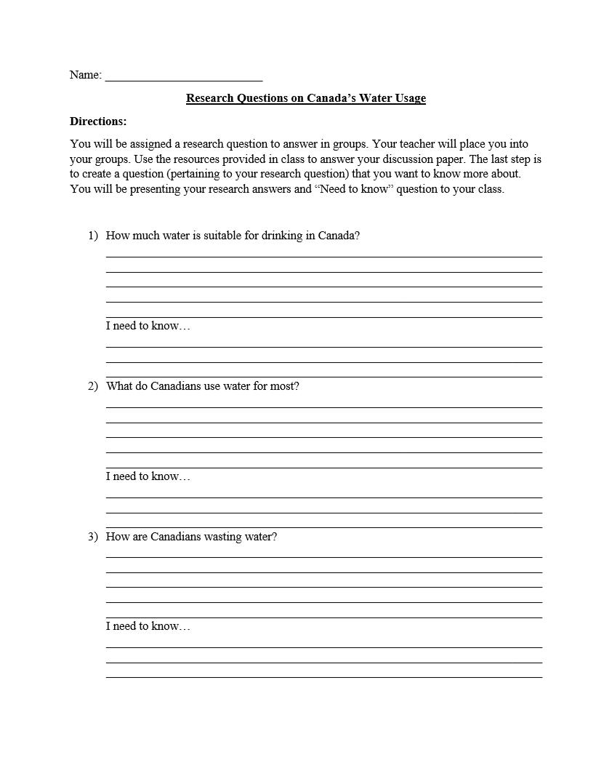
Appendix A
