Class Lesson Plan

Class: Grade 7/8 (30 students) Date: Tues Sept 3rd, 2019 Lesson Duration: 45 minutes
8:45am-9:30am

Title: Water advocates for respected countries, Intro and Research Period

Unit Plan: Fresh Water and Saltwater Systems – Water usage and cleanliness

Objective of Lesson (in own words):
- Students will participate in group work and explore multiple resources (Chrome book, and provided library books)
- Students will reflect on personal lived experiences as they explore elements of privilege
- Students will define the voice and experiences of individuals who are valued, silenced, or left out
- Students will be demonstrating their understanding of biases through research process
- Students will participate in in-class discussions

Learner Outcomes  Science  - identify science-related issues and problems (Alberta Education, 2014, p. 48)  - identify questions to investigate, arising from science-related issues (Alberta Education, 2014, p. 48)  - describe, in general terms, the distribution of water in Alberta, Canada and the world; and interpret information about water characteristics (Alberta Education, 2014, p. 47)  - identify current practices and technologies that affect water quality, evaluate environmental costs and benefits, and identify and evaluate alternatives (Alberta Education, 2014, p. 48)  Social Studies  - “develop skills of critical thinking and creative thinking” (Alberta Education, 2006, pg. 8)  - “demonstrate the ability to analyze local and current affairs” (Alberta Education, 2006, pg. 8)  - “develop skills of geographic thinking” (Alberta Education, 2006, pg. 8)  - “demonstrate skills of cooperation, conflict resolution and consensus building” (Alberta Education, 2006, pg. 9)  - “consider the needs and perspectives of others” (Alberta Education, 2006, pg. 9)  - “apply the research process” (Alberta Education, 2006, pg. 9)  - “draw conclusions based upon research and evidence” (Alberta Education, 2006, pg. 9)  - “organize and synthesize researched information” (Alberta Education, 2006, pg. 9)  - “practise the responsible and ethical use of information and technology” (Alberta Education, 2006, pg. 9)  English  - Listen and respond constructively to alternative ideas or opinions (Alberta Education, 2000, p. 15)  - Plan and organize data collection based on instructions, explanations and pre-established parameters (Alberta Education, 2000, p. 51)  - contribute collaboratively in group situations, by asking questions and building on the ideas of others (Alberta Education, 2000, p. 95)  - use quotation marks to identify information taken from secondary sources in own writing (Alberta Education, 2000, p. 81) | Plan for Diversity  - Have Learning Objective and reminders on board in preparation for class  - Provide “Global Guiding Questions (GGQ)” (Appendix A) to students who require structure  - Vocally give instructions on group work and guide the students time and direction wise  - Provide time reminders during presentation  - Collaborative learning  - Group students based on skill set  - Allow use of Chromebook to students who may require digital note taking  - Watch out for and assist students who have anxiety trying to establish “self” in group work  - Ensure all students are actively playing a role
Prerequisite Knowledge, Skills, Strategies  and Attitudes  - Students should come in with a positive attitude and eagerness to learn alongside peers  - Students should apply note taking during research period  - Students should demonstrate their critical analysis and uncovering biases skills through research  - Students need to be open and respectful towards perspective  - Students will work on accountability within a group setting | Preliminary Matters (Announcements, etc.)  - Go over Learning Objectives of the period  - Go over group work and presentation expectations  - Go over responsibility towards peers and self; before implementing group work  - Assure students that questions are welcome  - Track time and guide students throughout the group work

 | Time | What the teacher does. | What the student does. | Resources | Assessment
Introduction | 10 mins.  8:45-  8:55 | - Hand out GGQ worksheets as students walk in  - Announcement: Discuss the learning objective for the class  - Ask students to keep GGQ worksheet out on desk  - Announcement: Go over research, presentation expectations and respectful guidelines. Ensure questions are welcome if they don’t understand  - Ask students to put their hands up in recognition of guidelines  - Display assigned groups  - Ask students to get into their groups | - Follow along during instruction  - Agree to respect guidelines  - Get into groups | - GGQ worksheet | - Formative assessment: check to ensure that all students understand guidelines and check in if they understand expectations during group work
Grab your resources! | 5  mins.  8:55-  9:00 | - Give each group their book to assess.  - Hand out 2 chrome books/group  - Notify students after 5 mins that they should be in their groups and begin their research | - Students will grab provided library book  - Students will grab chrome books  - Students will assign responsibilities within group | - GGQ worksheet  - Additional hardcopy books (Appendix B/ References)  - Chrome books | - Formative assessment: scanning class to ensure that everyone is on the right track; check to ensure that all students have a role within the group; be present and keep personal note of students who have a harder time understanding group work
Group Work | 28 mins.  9:00-  9:28 | - Help students who may have their hands up  - Walk from group to group to ensure everyone is on track  - Announcement: Break down time to keep students on track | - Students should be actively sharing ideas and filling out worksheet  - Students should be sharing resources | - GGQ worksheet  - Additional hardcopy books (Appendix B/ References)  - Chrome books | - Formative assessment: scanning class to ensure that everyone is on the right track; be present and keep personal note of students who have a harder time with assessment.
Free time/ Wrap Up | 2 mins.  9:28-  9:30 | - Bring students back to center  - Remind students that they will be presenting their work tomorrow | - Listening to instruction | - N/A | - Formative assessment: scanning to make sure all students are listening on way out

Reflection **How did this lesson go over all? What would you change? What worked well?

Adapted from Alberta Education, Canada, 2008

References

Caparas, M.J. (2017). The Water Quality of Salcedo River, Salcedo, Eastern Samar, Philippines. Germany: LAP LAMBERT Academic Publishing.
Derman, B. (2007). Conflicts Over Land & Water in Africa: Cameroon, Ghana, Burkina Faso, West Africa, Sudan, South Africa, Zimbabwe, Kenya, Tanzania. Michigan: Michigan State University Press.
Hollyer, B. (2009) Our World of Water. New York City: Henry Holt and Co.
Leronimo, C. (2014) A Thirst for Home: A story of water across the world. New York: Walker Books for Young Readers.
Monteiro, S. (2015) Water: How to Turn the Tap Back on. Brazil: The Brazilian Economy.
Park, L.S. (2019) Nya’s Long Walk: A Step at a Time. New York: Clarion Books
Subhash, S.V. (2018). Water. India: Tara Books.
Verde, S. (2016). The Water Princess. New York: G.P. Putnam's Sons Books for Young Reader.

Appendix A

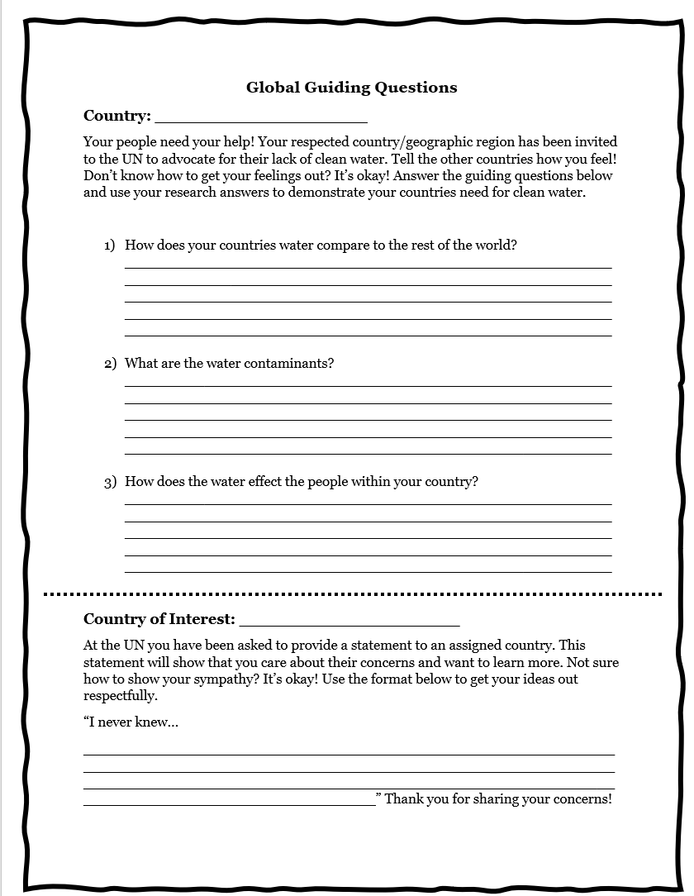
Appendix B

- Water by Subhash Singh Vyam
- Water: How to Turn the Tap Back On by Solange Monteiro
- A Thirst for Home: A story of water across the world by Christine Leronimo
- The Water Quality of Salcedo River, Salcedo, Eastern Samar, Philippines by Merry Jean Caparas
- Conflicts Over Land & Water in Africa: Cameroon, Ghana, Burkina Faso, West Africa, Sudan, South Africa, Zimbabwe, Kenya, Tanzania By Bill Derman
- Nya’s Long Walk: A Step at a Time by Linda Sue Park
- Our World of Water by Beatrice Hollyer
- The Water Princess by Susan Verde

