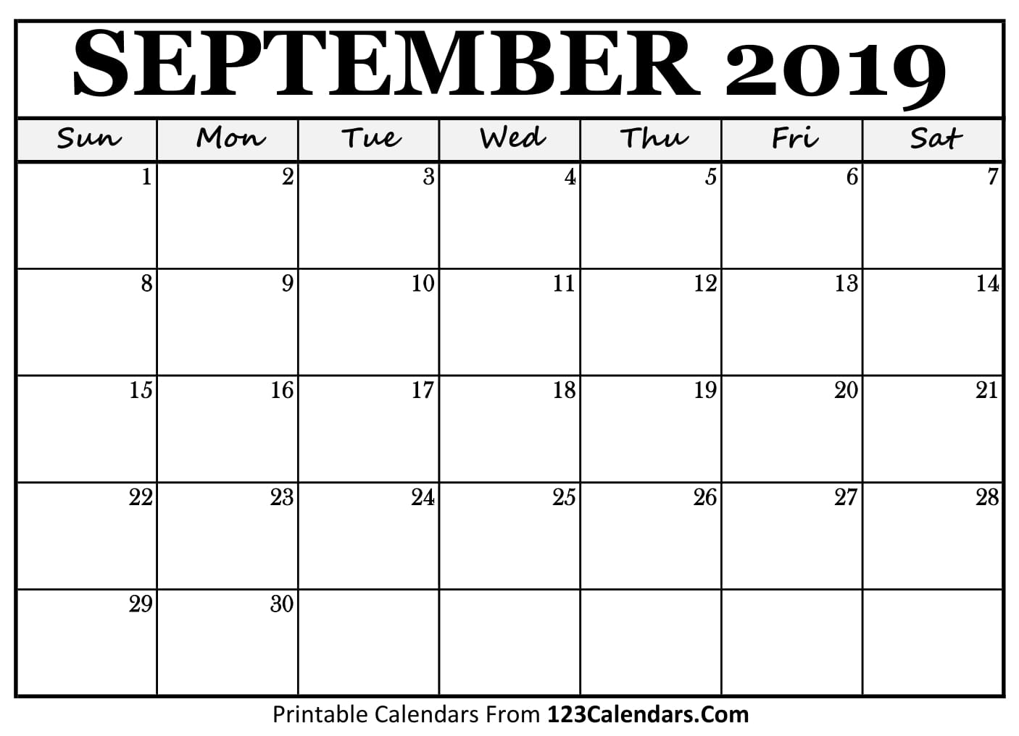
- Students participate
in Socrative conversations.
- 1 group leader from each group will present findings for research question and ask 1 question to class that they want to know more about

- Students will pick 2 new
books and read with group from day before
- Students will work on personal reflection in English journal with guiding questions on provided worksheet

- Day #1 Experiment #1
- Students get together in assigned groups to put together science experiment
- Groups are assigned based on skill set

EXPERIMENT: Each week, students will participate in their water filter science experiment in order to complete their summative assess.
OBJECTIVE: We want our students to understand the difficulties of water sustainability on not just a global scale but within the very country they live in.
- Award students with Disney Nature: Oceans Movie

SUMMATIVE ASSESSMENT: Students will present their findings on their science experiment and tie their results back to how water effects citizens in a home and global scale
- Work Period: Students
will spend class time working together and organizing ideas for their summative assignment.

- Introduction to water use in Canada
- Discuss guiding questions with class
- TopHat: personal water usage (formative asses.)
- Kahoot: water use in Canada

- Award students with Disney Nature: Oceans Movie

- Presentation Day:
Students are presenting their summative assess. in groups

- Presentation Day: Students are presenting their summative assess. in groups

- Work Period: Students
Are working on finishing touches for presentation
- Flex day to assess where everyone is at on their summative assess.

- Work Period: Students
will spend class time working together and organizing ideas for their summative assignment.

- Day #1 Experiment #3
- Students get together in assigned groups to put together final science experiment
- Groups remain the same from first two weeks

- Day #2 Experiment #3
- Students will conduct experiment constructed from day before and record research in their science journal

- Book review
- Present a series of picture books to your students
- In groups, students will choose 1 book, critique the book, and answer worksheet

- Introduction to state of
water on indigenous
reserves within Canada
- The Danger of a single story
- YouTube Video on water on reserves
- Discuss Guiding Questions

- Day #2 Experiment #2
- Students will conduct experiment constructed from day before and record research in their science journal

- Day #1 Experiment #2
- Students get together in assigned groups to put together science experiment
- Groups remain the same from first week

- Students will be assigned
1 research question and make up 1 “Need to know” question
- Students will be assigned into groups and be provided resources to assist in answering research questions

- Day #2 Experiment #1
- Students will conduct experiment constructed from day before and record research in their science journal

- Each group will present their research
- Other students will answer worksheet questions pertaining to the presented groups assigned country

- Group work: Students will be placed into groups
- Research: Students will be provided a series of questions to research on the their assigned country’s water cleanliness

- Direct Instruction day
- Introduction to water cleanliness on a global scale
- Discuss guiding questions with class

- Text: Anya’s Ghost
- Grade Level: Grade 10-1
- Duration: 85 min classes

