Class Lesson Plan

Class: Grade 7/8 (30 students) Date: Wed Sept 18th, 2019 Lesson Duration: 45 minutes
8:45am-9:30am

Title: Independent Book Analysis

Unit Plan: Fresh Water and Saltwater Systems – Water usage and cleanliness

Objective of Lesson (in own words):
- Students will participate in learning about water pollution and the state of water cleanliness on First Nation Reserves within Canada
- Students will reflect on personal lived experiences as they explore elements of privilege
- Students will do a critique on 1 book and reflect on the context
- Students will uncover biases and work on compare and contrasts on strengths and weaknesses

Learner Outcomes  Science  - identify science-related issues and problems (Alberta Education, 2014, p. 48)  - identify questions to investigate, arising from science-related issues (Alberta Education, 2014, p. 48)  - analyze human water uses, and identify the nature and scope of impacts resulting from different uses (Alberta Education, 2014, p. 48)  Social Studies  - “demonstrate skills of oral, written and visual literacy” (Alberta Education, 2006, pg. 9)  - “communicate information in a clear, persuasive and engaging manner, through written and oral means” (Alberta Education, 2006, pg. 9)  - “elicit, clarify and respond appropriately to questions, ideas and multiple points of view in discussions” (Alberta Education, 2006, pg. 9)  - “apply the research process” (Alberta Education, 2006, pg. 9)  - “develop a position that is supported by information gathered through research” (Alberta Education, 2006, pg. 9)  - “draw conclusions based upon research and evidence” (Alberta Education, 2006, pg. 9)  English  - scan to locate specific information quickly; summarize and record information useful for research purposes (Alberta Education, 2000, p. 55)  - reflect on ideas and information to form own opinions with evidence to support them (Alberta Education, 2000, p. 59)  - connect new information with prior knowledge to build new understanding (Alberta Education, 2000, p. 59) | Plan for Diversity  - Have Learning Objective and reminders on board in preparation for class  - Provide students with handout on guiding questions for book analysis (Appendix A)  - Students will remain in groups from day before so that they have an avenue for conversation if they need help on book analysis  - Have guiding questions on display so that students have multiple points of view  - Eliminate some questions for students who may experience anxiety when overwhelmed  - Students will have access to a series of books to choose from to critique (Appendix B/ References)  - Chrome books will be made available
Prerequisite Knowledge, Skills, Strategies  and Attitudes  - Students should come in with a positive attitude and eagerness to learn alongside peers  - Students will be working on their cognitive skills  - Students should demonstrate their critical analysis and uncovering biases skills  - Students need to be open and respectful towards perspective  - Students will respect their peers as they share class material | Preliminary Matters (Announcements, etc.)  - Go over Learning Objectives of the period  - Go over responsibility towards peers and self during class discussions  - Assure students that questions are welcome

 | Time | What the teacher does. | What the student does. | Resources | Assessment
Introduction | 5 mins.  8:45-  8:50 | - Announcement: Discuss the learning objective for the class  - Ask students to take out English Journal  - Ask students to get into their groups from day before and pick two books, different from the one they critiqued as a group from the day before | - Take out English Journals  - Pick 1 book per group  - Get into group | - English Journal  - Additional hardcopy books (Appendix B/ References) | - Formative assessment: check to make sure all students have their English journals out and are paying attention as they get into their groups
Share your sources | 10  mins.  8:50-  9:00 | - Ask students to elect two readers to the group.  - Give directions to book analysis  - Walk around to make sure everyone is on track and listening to the readers  - Hand out guiding question worksheets to each student while they are working together  - Handout 2 chrome books per group  - Announcement: Tell students that as soon as they are done reading, to start on their personal analysis  - Track time for students | - Listen to peers read  - Read to peers  - Get started on personal analysis if applicable | - English Journal  - Additional hardcopy books (Appendix B/ References)  - Book analysis question worksheets  - Chrome book | - Formative assessment: visually checking to ensure students are on track
Personal Book Analysis | 28  mins.  9:00-  9:28 | - Walk around to assist students who need help  - Inform students that the only time they can converse with peers is when directed on worksheet. Everything is individual work  - Track time for students | - Students will work on personal analysis of both books  - Students will share chrome book for very light research  - Students will work in a respectable volume during this workshop | - English Journal  - Additional hardcopy books (Appendix B/ References)  - Book analysis question worksheets  - Chrome book | - Formative assessment: visually checking to ensure students are on track  - Formative Assessment: Assess students learning curve from group book analysis from day before
Free time/Wrap Up | 2 mins.  9:28-  9:30 | - Ask students to come in tomorrow, get into experiment groups, take out Science journal first thing, and remind students that Experiment #3 is tomorrow and they should not wear their best clothes | - N/A | - N/A | - Formative assessment: scanning to make sure all students are listening

Reflection **How did this lesson go over all? What would you change? What worked well?

Adapted from Alberta Education, Canada, 2008

References
Brownbill, K. (Ed.). (2016). The Ojibwe of Great Spirit Island (Vol. 1). Newfoundland: Canoe Kids.
Donovan, N. (2017). The Sockeye Salmon. Winnipeg, MB: HighWater Press.
Inhabit Education. (2019). How we Use Water. Toronto, ON: Inhabit Education.
McLeod, J., & Willet, M. (2008). The Delta is my Home. Calgary, AB: Fifth House Books.
Robertson, J. (2017). The Water Walker. Toronto, ON: Second Story Press.
Tenasco, S. (2019). Nibi’s Water Song. Malaysia: North Winds Press.

Tudor, A., & Tudor, K. (2018) Young water protectors : a story about Standing Rock. Calgary: AB: EagleSpeaker Publishing.

Vebæk, M. (2019) A Journey to the Mother of the Sea. Toronto, ON: Inhabit Media Inc.

Waboose, J. B (1997). Morning on the Lake. Toronto: ON: Kids Can Press.

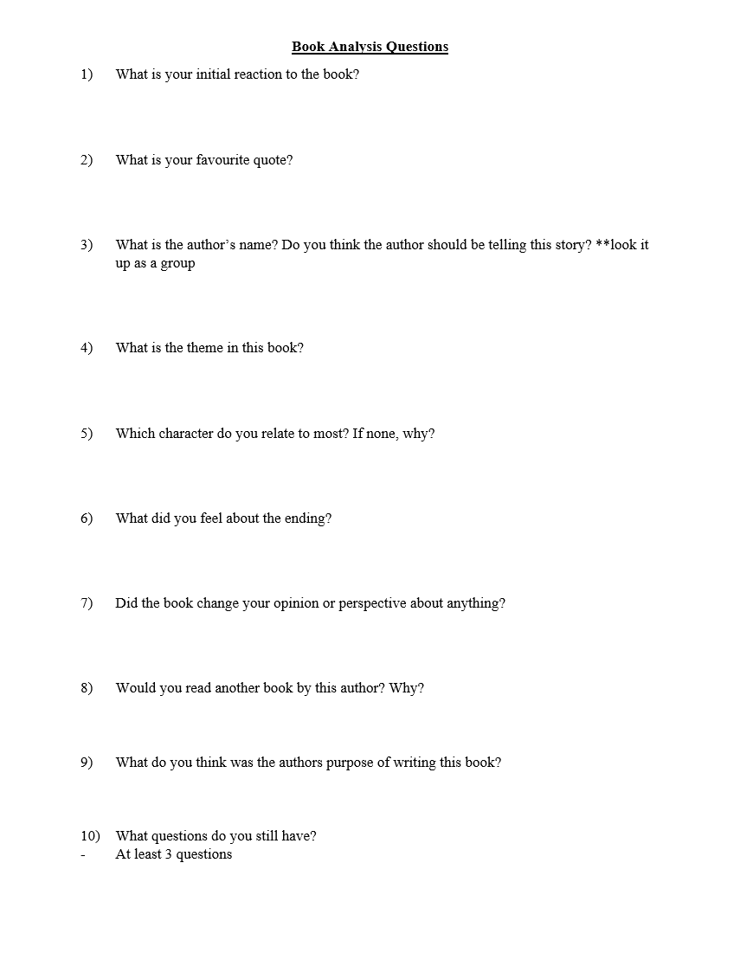
Appendix A
Appendix B

- The Sockeye Mother by Natasha Donovan
- The Delta is my Home by Tom McLeod and Mindy Willett
- The Ojibwe of Great Spirit Island (Volume 1- Canoe Kinds) by Kelly Brownbill
- The Water Walker by Joanne Robertson
- Young water protectors: a story about Standing Rock by Aslan Tudor and Kelly Tudor
- Nibi’s Water Song by Sunshine Tenasco
- A Journey to the Mother of the Sea by Mâliâraq Vebæk
- Morning on the Lake by Jan Bourdeau Waboose
- Nunavummi Reading Series: How We Use Water by Inhabit Education

